NIHR HRC: Emergency and Acute Care –
Email signatures

How to use the templates

- Replace placeholder fields with your details (delete rows as necessary)
- Copy the signature

In Outlook:

- Open ‘New Email’
- Select the ‘Signature’ icon → Signatures
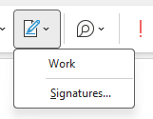

- Select ‘New’ and add title
- Paste the signature into the textbox
- Save

---------

HRC / MFT

Name
Title
Pronouns: [ / ]
 | 
Address
T: [Telephone]
E: [Email address]
[Website link]

---------

HRC / MFT / UoM

Name
Title
Pronouns: [ / ]

Address
T: [Telephone number]
E: [Email address]
[Website link]

